Field mapping with QGIS, INPUT and QFIELD

Tim Sutton

Chapter 1. Introduction 3

Chapter 2. Building your QGIS project 4

1.1. Virtual layer for trees as polygons based on crown radius 4

1.2. Image in drag and drop forms 5

1.3. Feature info 7

1.4. Control which layers are editable in INPUT 8

1.5. Bundling SVG’s 9

1.6. Using a different marker style for points with images 11

1.7. Building the plant type form 13

1.8. Plant point to plant type value relation 15

1.9. Label for plant points layer 16

1.10. Tooltips for POI 20

1.11. Using QML Form Widgets 24

Chapter 3. Getting out into the field 26

1.1. External GPS receivers 26

1.2. Using INPUT in the field 26

1.3. Using QField in the field 26

Chapter 4. Synchronising field data back to your office 26

1.4. Synchronizing INPUT data 26

1.5. Synchronizing QField data 26

Chapter 5. Further reading and resources 27

1.6. More INPUT info 27

1.7. Input versus QField 27

# Introduction

## Conventions used in this book

QGIS expressions and similar ‘code’ examples are written in fixed width font blocks like this:

If (image is null, True, False)

Instructions to select an item from the menus and the QGIS or app user interfaces are written like this:

File -> Save Project

Sometimes there are special hints and tips that you may want to be aware of whilst working through these materials. We will present such tips like this in this book:

**Note:** You can save time in your field mapping preparation by reading this book!

## Purpose of this book

QGIS has come a long way since its humble beginnings in 2002 when Gary Sherman (founder of the QGIS project) released the first version of the project as publicly shared source code. Now many organizations around the world use QGIS for carrying out their mission critical GIS activities. More recently, QGIS has made its way to the mobile platform. It was first ported as a complete port of the QGIS Desktop application so that tablet users could use the same features on their devices. Following that, QGIS was used as the underlying software for two native mobile applications (first QField, then INPUT) which use the QGIS rendering engine to display map data, but provide mobile optimized user interfaces. QField and INPUT are primarily intended to be used for field data collection – the process where GPS or similar positional information is collected in the field along with observations about the on-the-ground situation in the field. The data collected on the table is then synchronized to desktop computers in the back-office environment for further visualization and analysis.

The purpose of this book is to help GIS practitioners who want to understand the process of planning and executing a field data gathering programme to do so with confidence and using best practices.

## Prerequisites

This book assumes that you already have a moderate to advanced working knowledge of QGIS already. As such, basic QGIS concepts such as styling, layer creation etc. are not explained in this book. Where practical we provide links to other documentations sources that do explain these concepts.

## An overview of INPUT and MERGIN

## An overview of QFIELD and QField Sync

# Building your QGIS project

I know you are eager to get out into the field and start mapping! Before we can do that though, we need to build a QGIS project that will be used as the basis for our field mapping work. There are many different approaches you can use to create your field mapping project and some of the decisions you make depend on the environment you will be mapping in.

For example, if you can be sure that you will have internet access (via WIFI, 4G or similar) you might consider using network-dependent layers. These could be contextual layers published as ‘XYZ tile layers’, Web Mapping Service (WMS) [1]layers, Web Feature Service (WFS)[2] layers which provide non-editable ‘backdrop’ information for your field mapping activities. Alternatively, you could use WFS or remote database layers for the actual data collection layers that you intend to update or augment in the field. Depending on the quality of the data connection you have in the field and the amount of data represented in your remote layers, this system may work well or prove to be sluggish as you wait for data to move between your device and the server over the network connection.

Another approach is to design your field data collection processes in a way that all data is taken offline, stored in the device’s local storage. This removes any latency issues due to slow or unstable connectivity, but presents new challenges when returning from the field and merging field data back into your desktop environment.

The complexity increases when you work in a multi-user environment and have many asynchronous changes happening to the same data layers that then need to be merged in a clean way into the master dataset. For example, what will happen if two field workers edit the same feature while in the field? Which changes should be accepted and which rejected?

This book assumes that we are working in a disconnected environment in the field and that we have a single user with exclusive access to the datasets being managed. We will use the geopackage as the data format since it provides many of the advantages of a relational database environment, overcomes many of the limitations of the ESRI ‘shapefile’ (don’t use shapefiles!).

Another consideration when planning your QGIS project is the fact that you will likely use the same project both on your desktop computer and on your mobile device. In general, everything you do on the desktop can be ported with little or no modifications to the mobile application environment, but there are some exceptions. For example, you may need to embed SVG symbols in your project, some layer types may not work in the mobile context (e.g. virtual layers), some features such as map tips may need special handling to work on the mobile device, and so on.

## Understanding and managing layer styles

## Understanding QGIS Map Themes

The first thing you should get to grips with in QGIS is the concept of map themes. QGIS Uses themes to let you quickly switch between cartographic styles in your project. You can also use themes in map composer to present the same data with different cartographic presentations in different map items on the layout. Map themes are managed from within the **Layers Panel** as shown below.



The theme system manages:

1. Which layers are visible
2. Which layer groups are visible
3. Which styles are active for each layer

For building our project we will have at least two themes:

1. A theme for working with your data on QGIS desktop.
2. A theme for working with your data on the mobile platform.

You may want to selectively create additional themes – for example to create separate cartographic profiles for when there is internet connectivity versus when there isn’t.

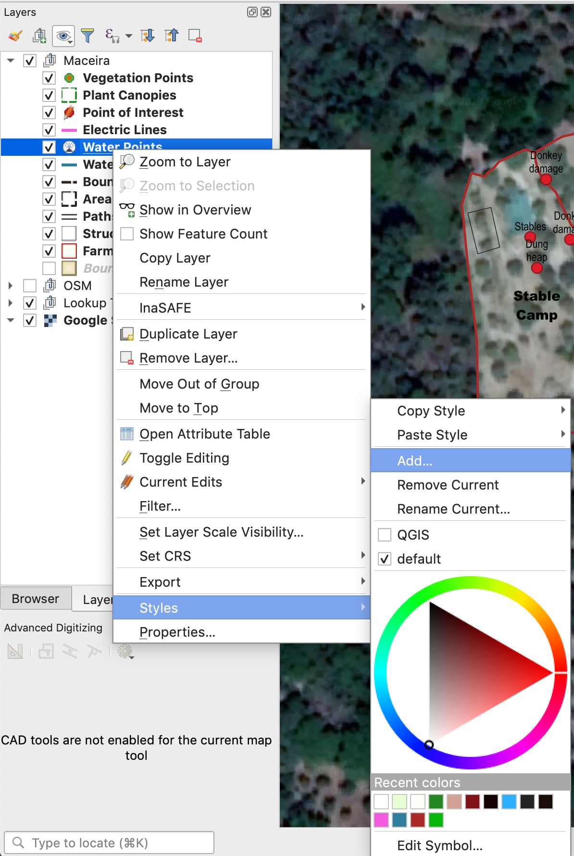

## Virtual layer for trees as polygons based on crown radius

select   
 fid,   
 st_buffer(  
 MakePoint(  
 X(geometry), Y(geometry)), crown_radius_m) as geom /*:polygon:20790*/,   
 X(geometry) /*:int*/ as x,   
 Y(geometry) /*:int*/ as y,   
 type /*:string*/ from “Vegetation Points”;

Note the special annotation to indicate the geometry type and CRS.

I had a bit of a fiddle around - you should really be able to just offer the geometry directly but I first needed to reconstruct the point - perhaps because it is a 25D point.

Take care to add the type and CRS annotations especially for the geometry field.

See <https://docs.qgis.org/2.14/en/docs/user_manual/working_with_vector/virtual_layers.html> for more info on virtual layers.

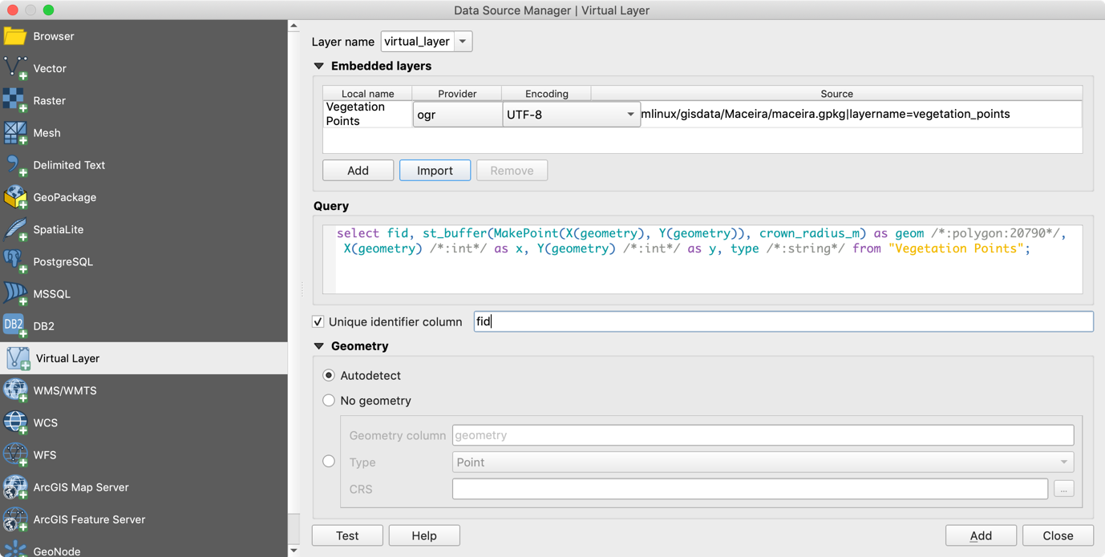

Result:



## Image in drag and drop forms

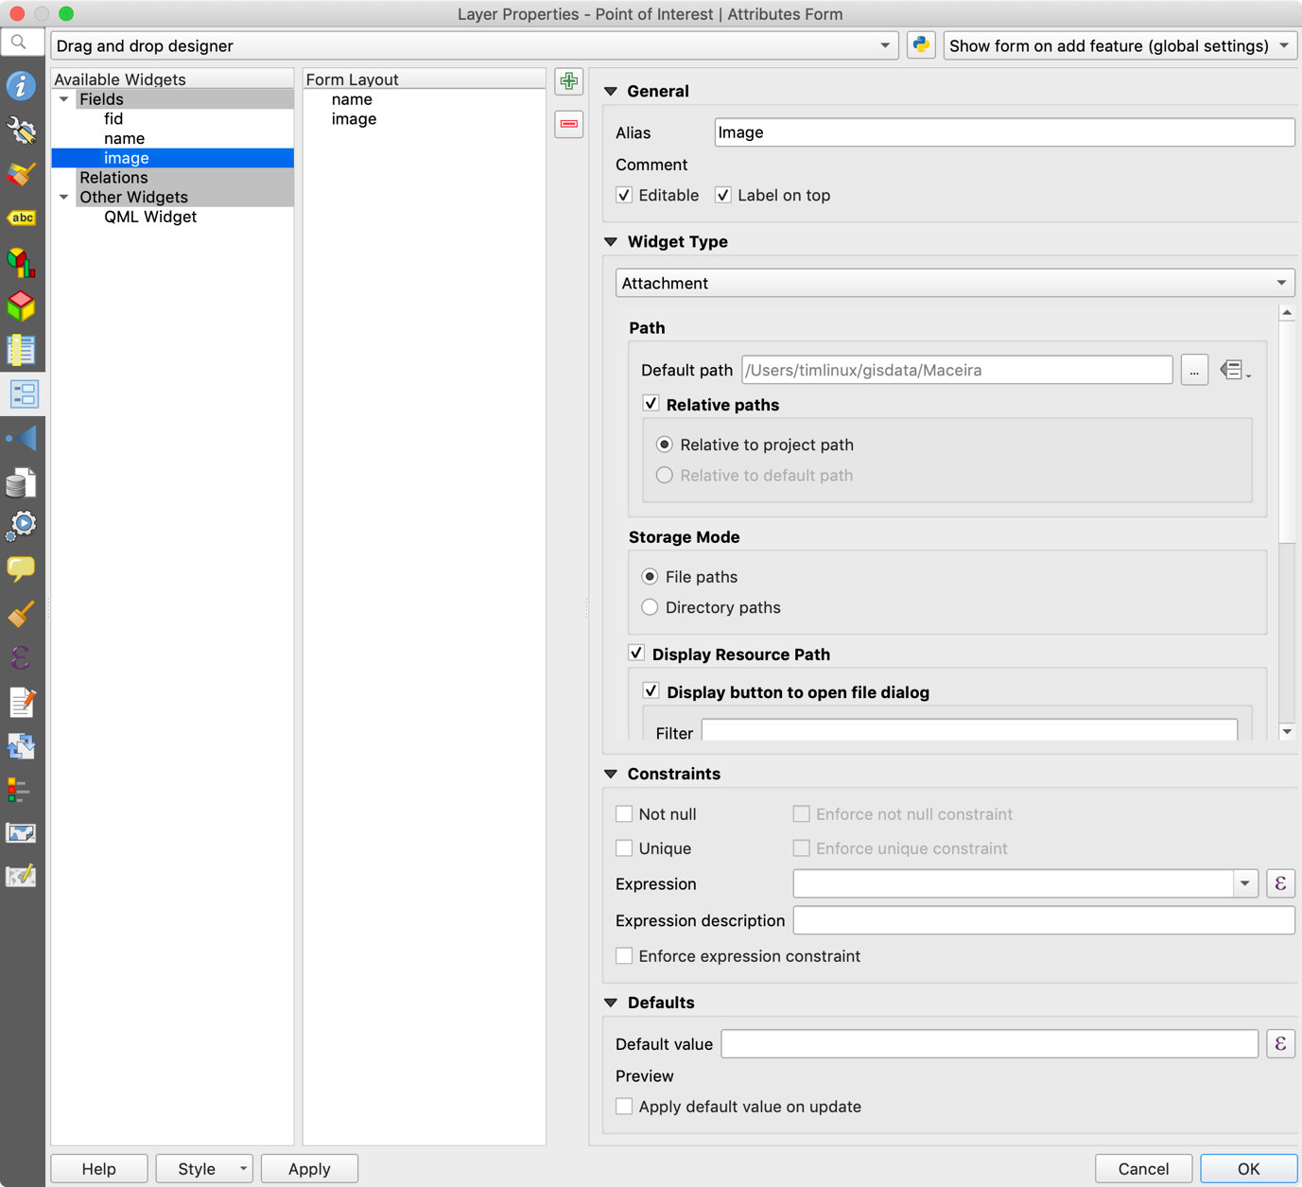

Also make sure to set the widget type properly like this:



## Feature info

Use the QGIS Layer tooltips option to et that up

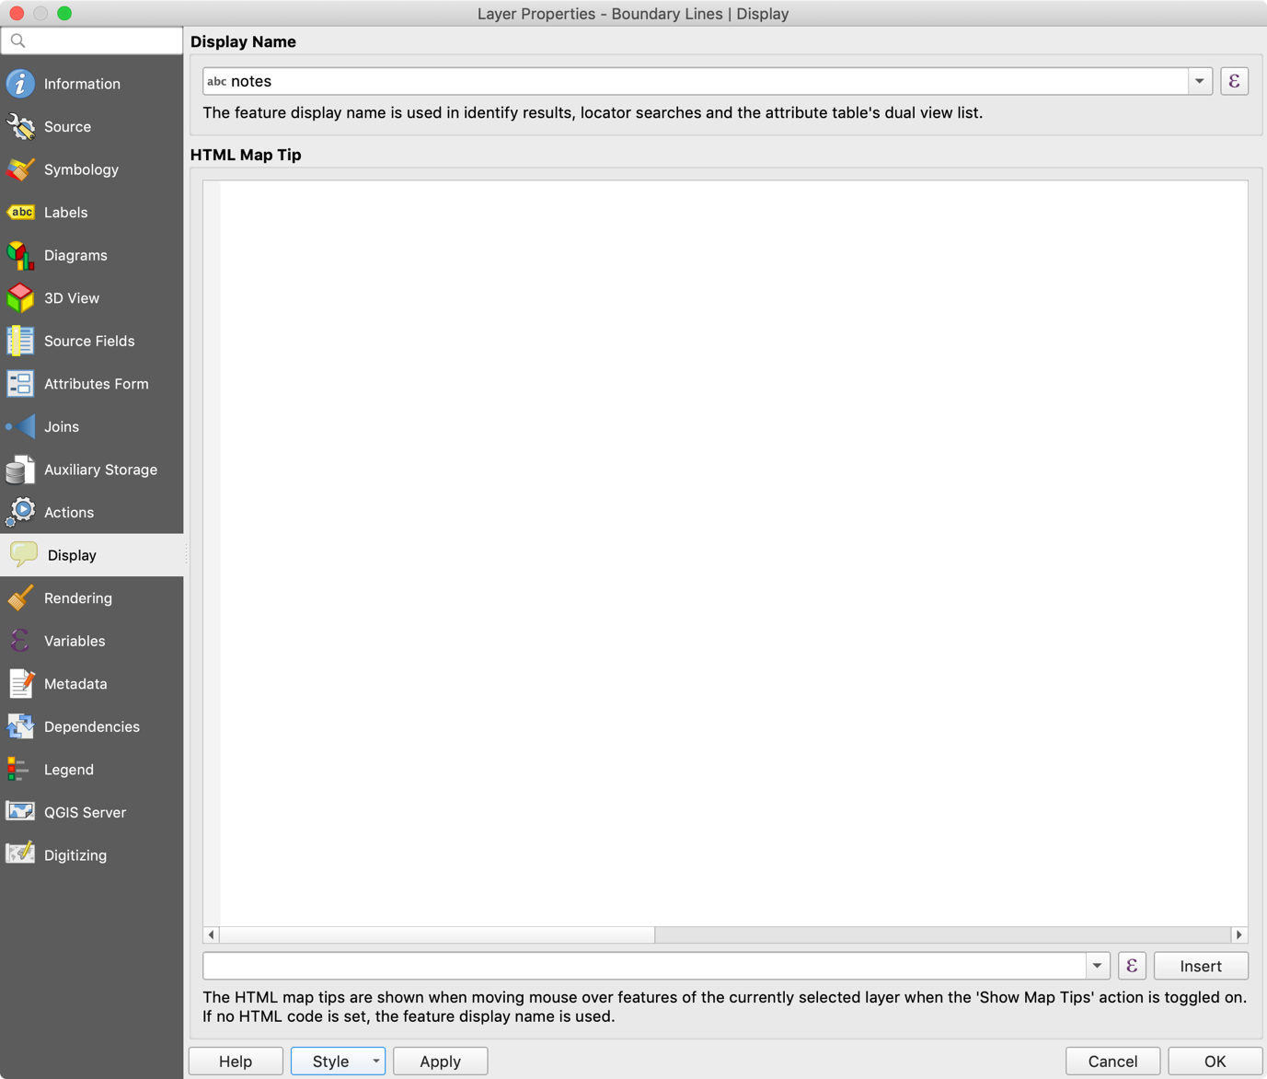

## Control which layers are editable in INPUT

You can open project properties and nominate specific layers to be editable. The rest will be show in read only (both in QGIS Desktop and in Input).

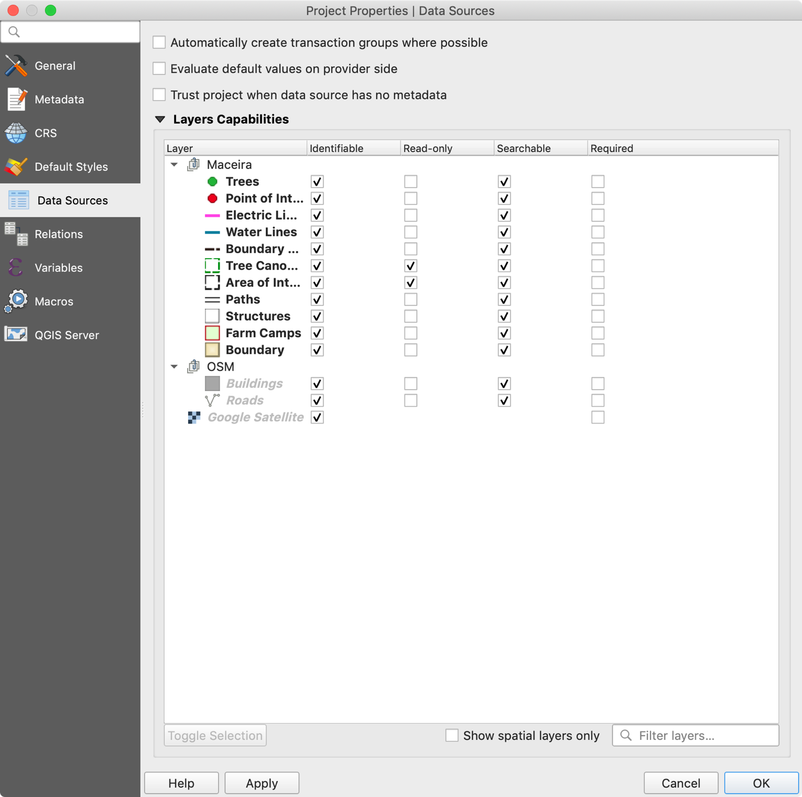

## Bundling SVG’s

Input does not ship all of the SVG icons shipped with QGIS.

Instead you should use the ‘embed’ option for your chosen SVG markers.

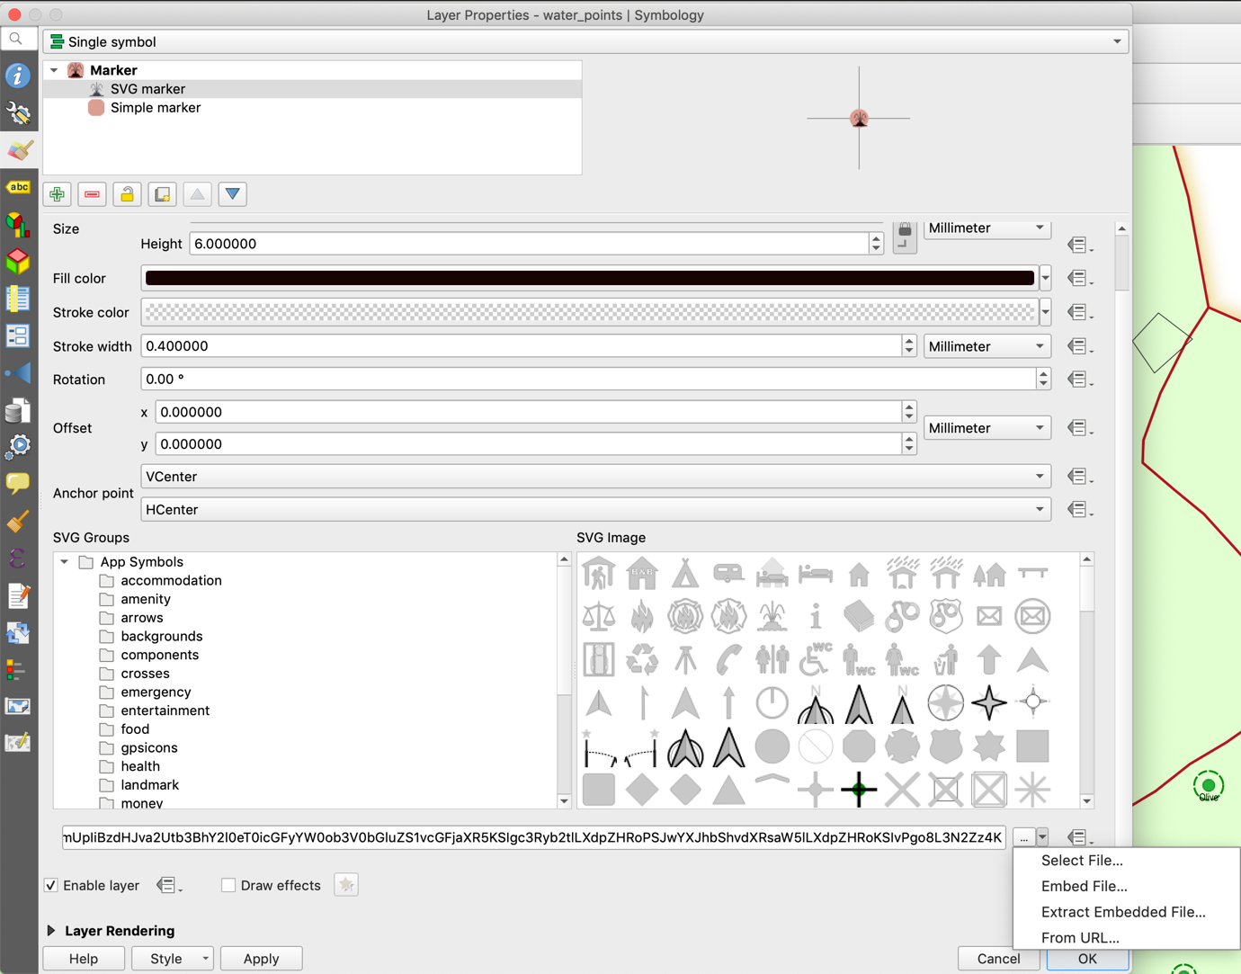

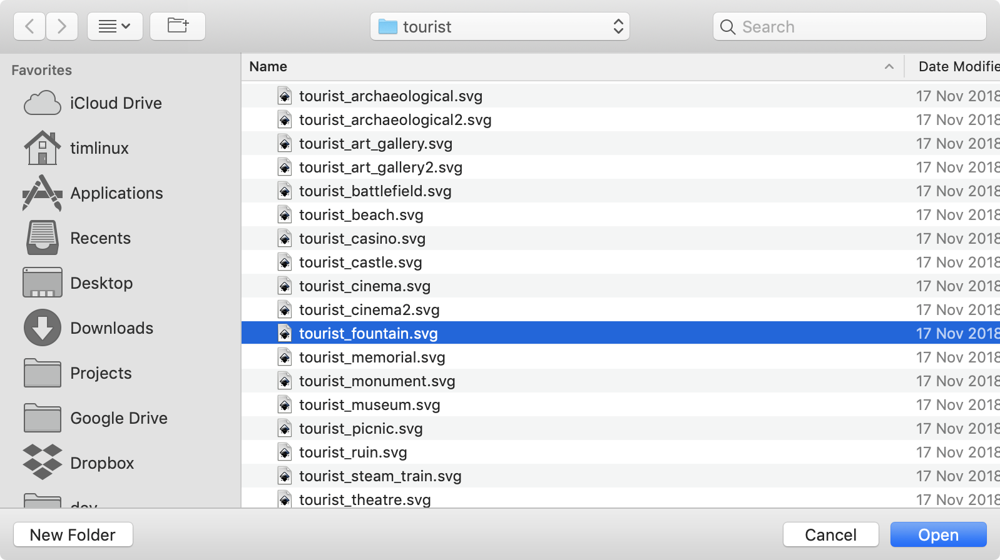

## Using a different marker style for points with images

I did this so I could see which surveyed trees had images taken for them.

I added an additional symbol layer.

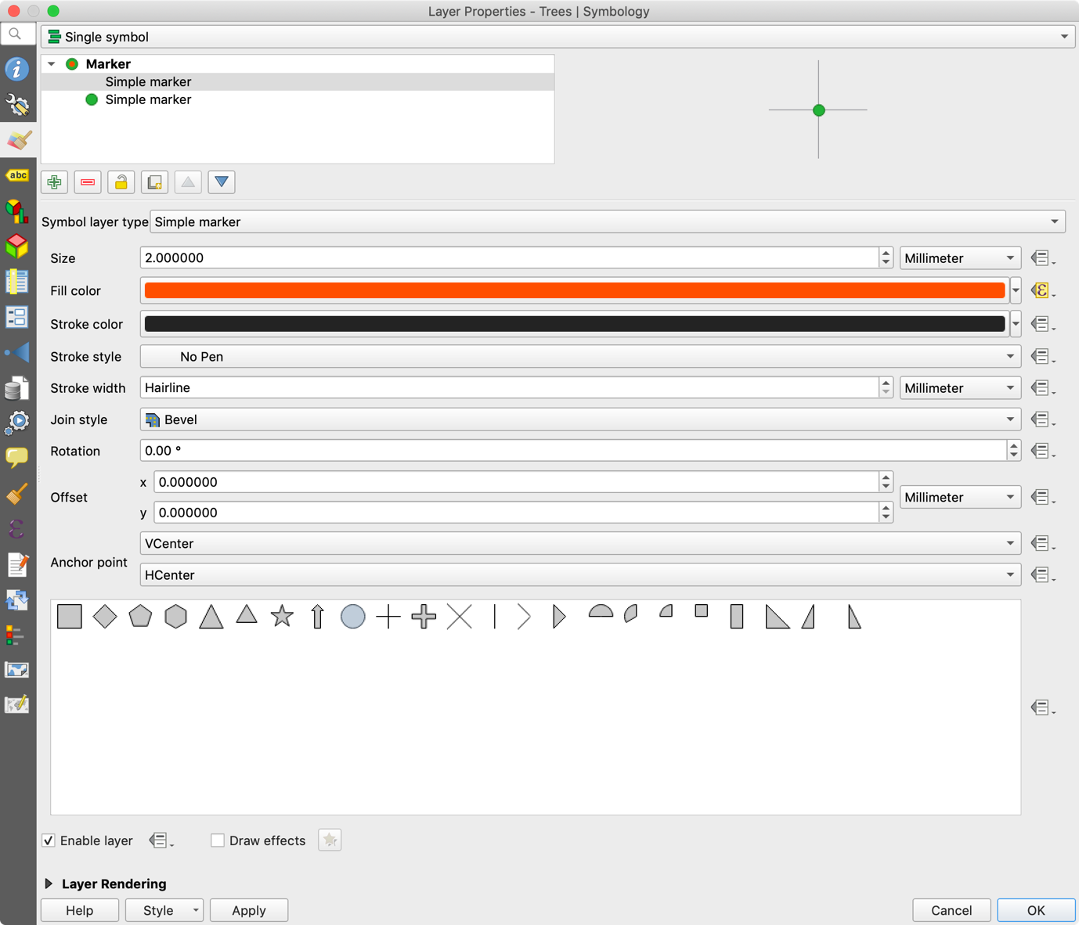

Then changed the colour based on whether the ‘image’ field is null or not:

if (image IS NOT NULL, '#00FFFFFF', '#FFFFFFFF')



Now trees with no photos get a white dot inside ring around their markers…

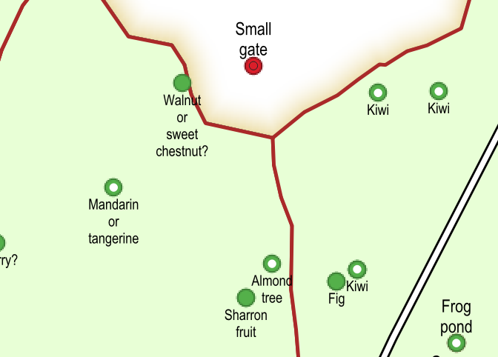

## Building the plant type form

One of the more complex forms I created is the plant_type table’s form. It will be used as a look up table when capturing trees and plants on the smallholding, and also store useful management information for when I create reports and map series. One of the things I wanted to store was the flowering month, fruiting month and pruning month for each plant species. I created another lookup table ‘month_lookup’ that contains one entry per month of the year. Using that lookup I can let the user choose a month by name but store the month number (1-12) in the plant_type table. I used the “load data from layer” option to populate the list of allowed month values.

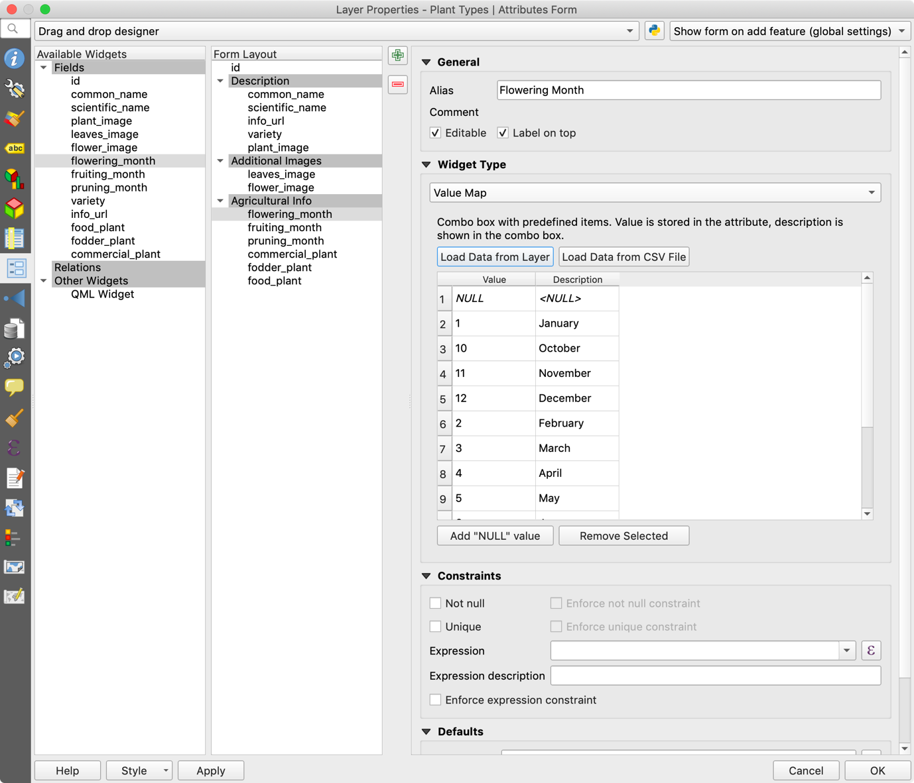

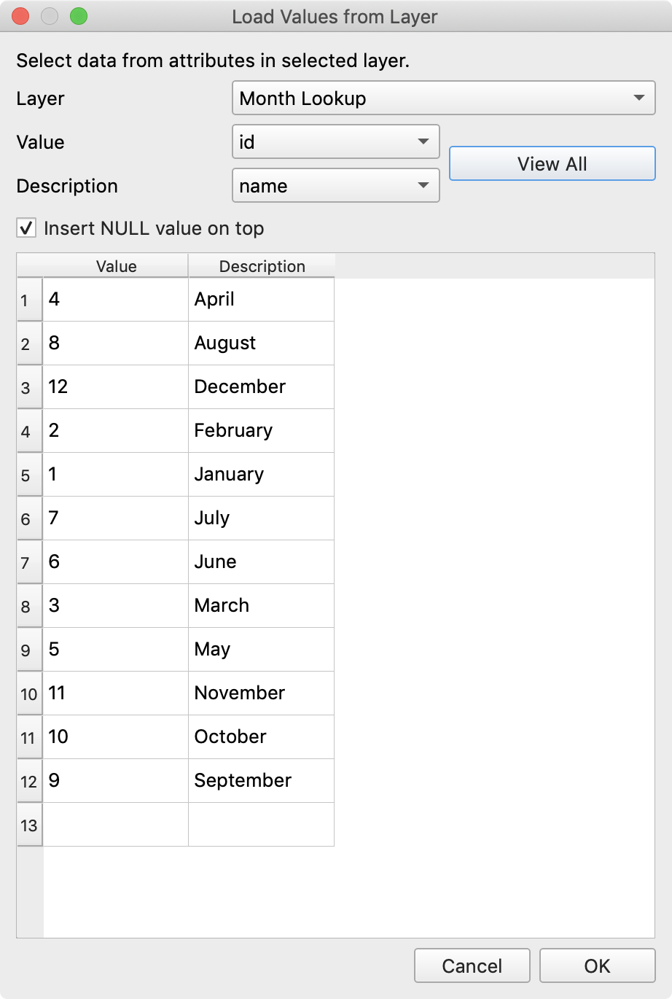

One problem we have with this is that the values are not presented in ascending order so when using the form, it looks like this:

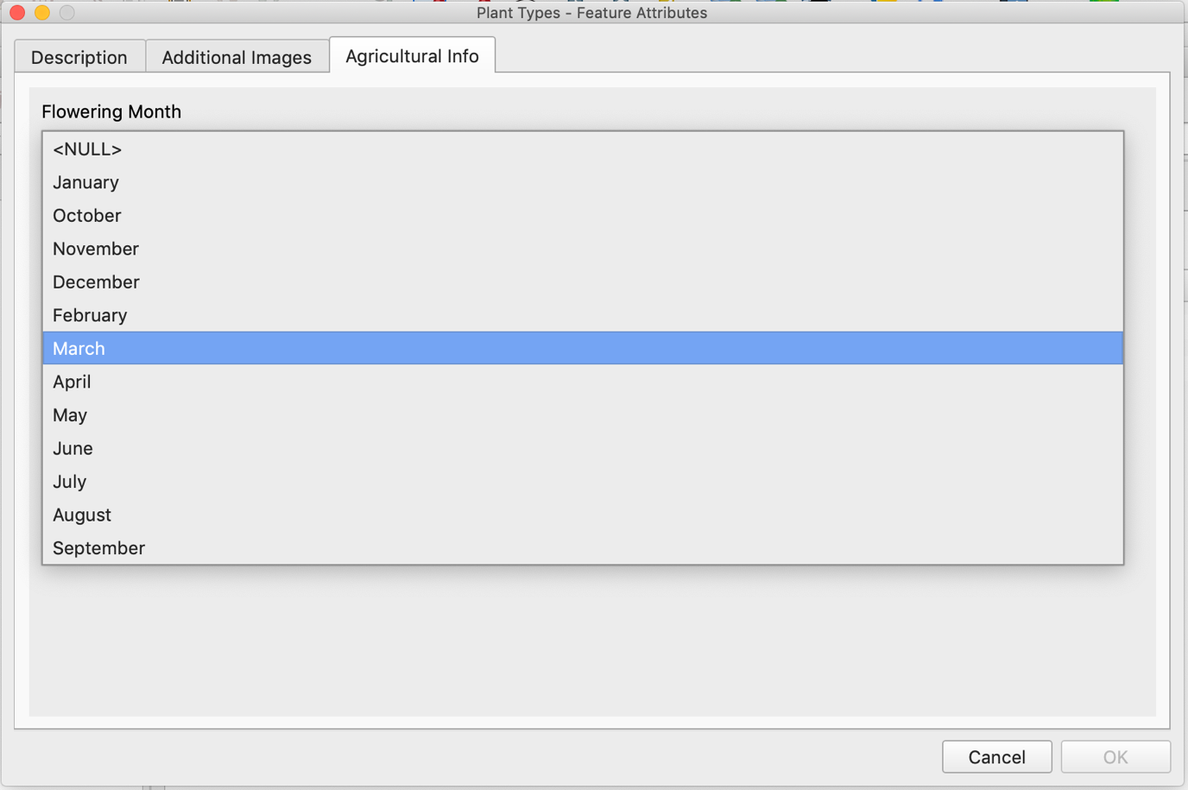

## Plant point to plant type value relation

For the trees layer we want to refer to a plant type from the plant type table so that the user can pick a plant easily, but also that we have a normalised structure that we can use to do some more interesting analysis and reporting on later.

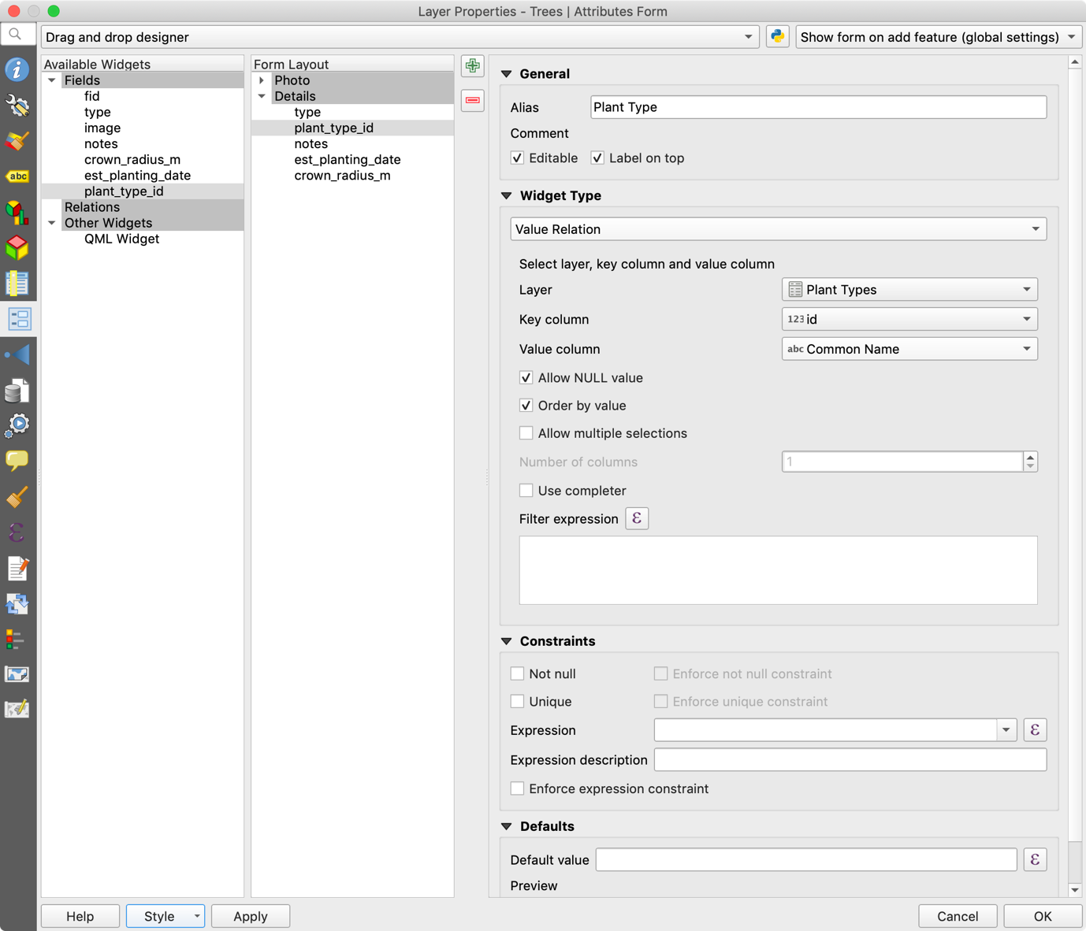

## Label for plant points layer

Because the plant type is linked to a related table, we can create a relationship with the plant_type table and bring in the common name from there to use in our labels.

Add a new relation in the layer properties:

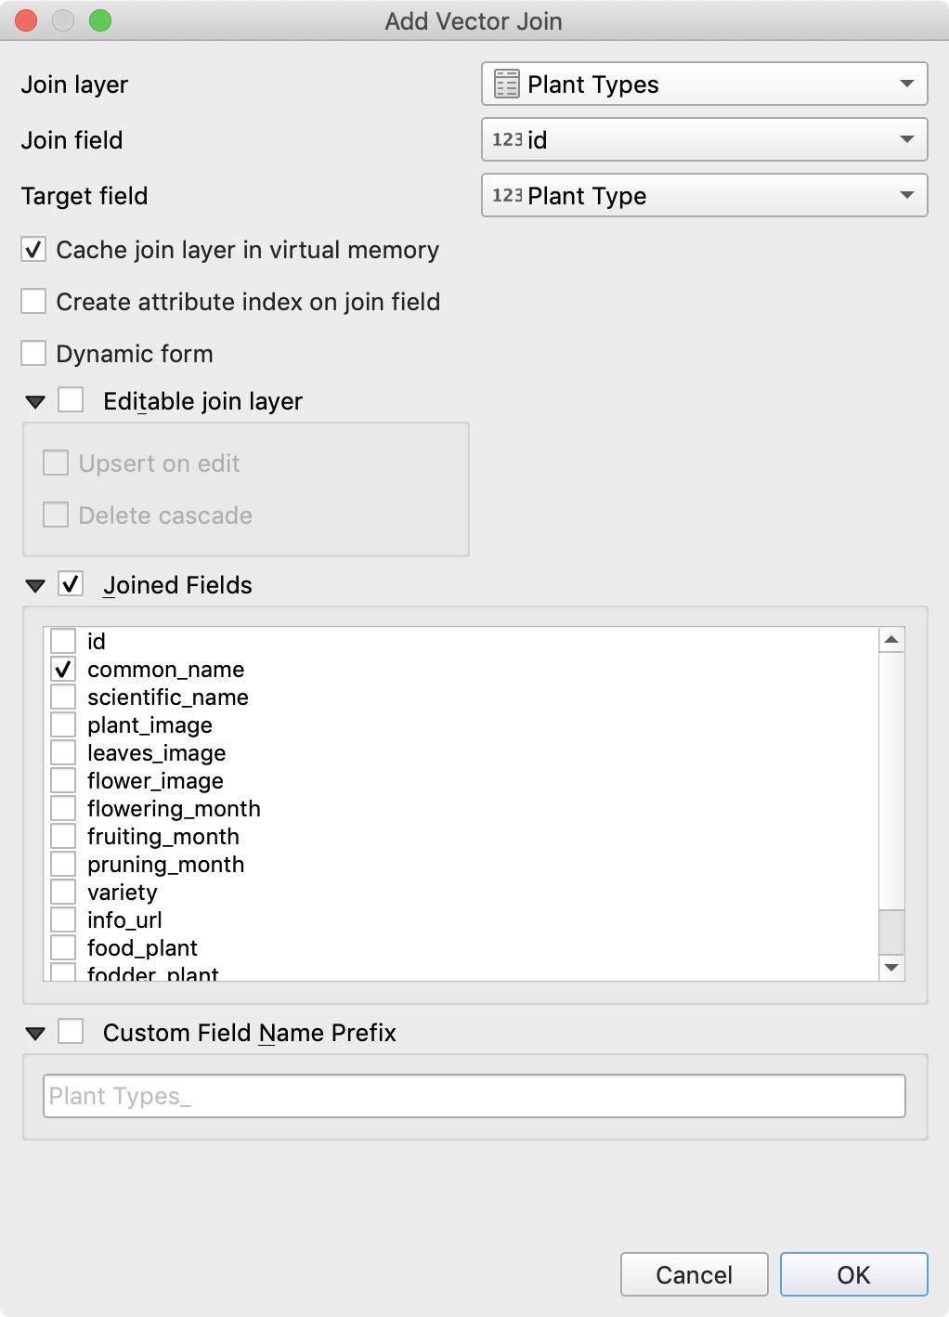

After adding the relation your layer property relations should then look like this:



For your label then you can select the related common_name field.

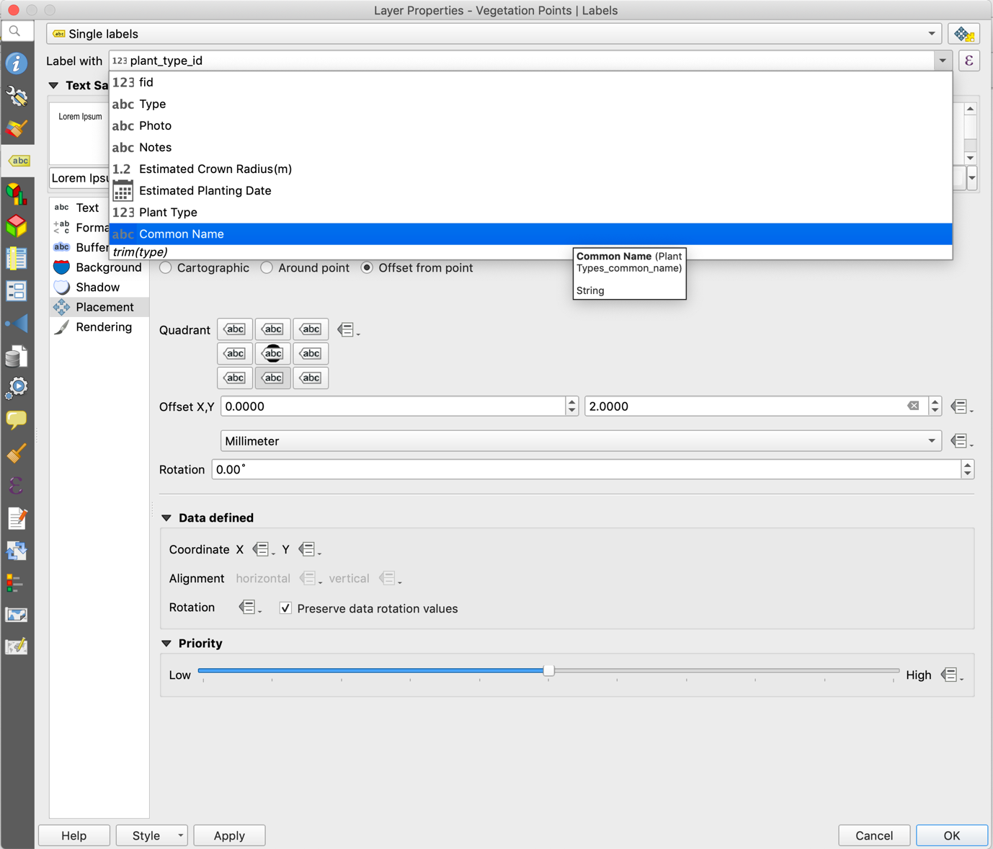

Now you will see the plant name nicely shown for each plant record.

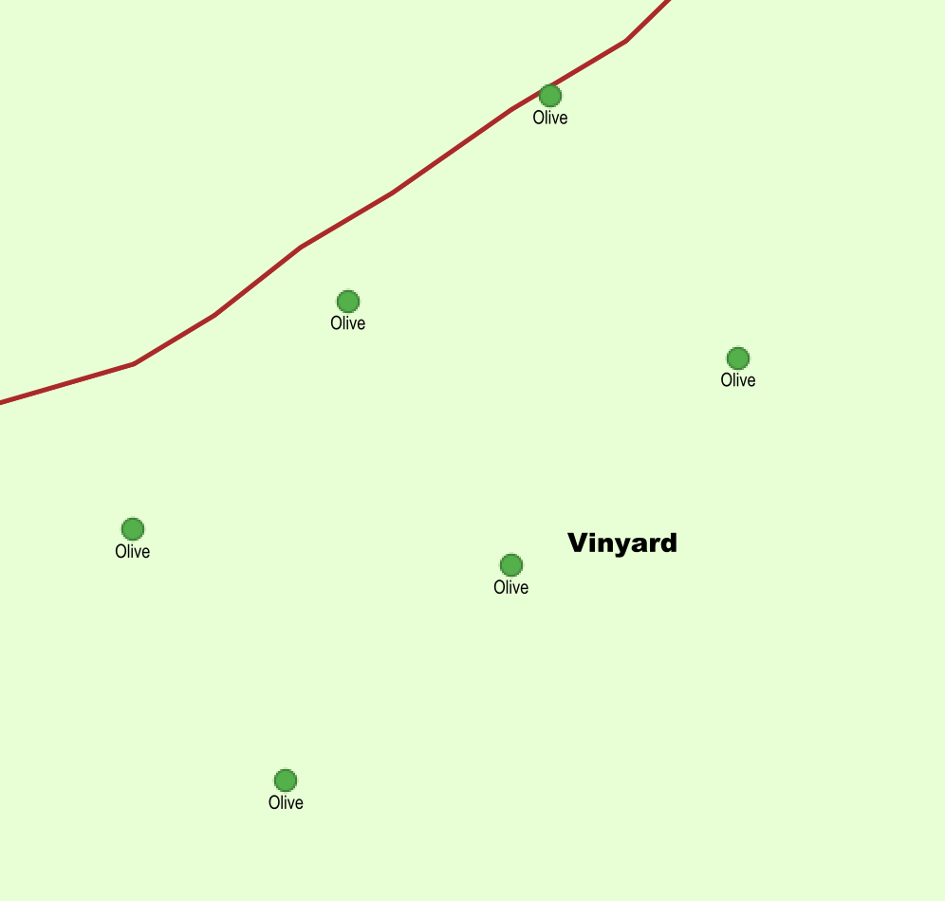

## Tooltips for POI

When you long press a feature in INPUT it will bring up a panel showing basic feature info. You can use tooltips to determine what is shown in that panel. From Saber (one of the INPUT authors):

*“the long press is similar to google map: it will bring up the attribute table and tooltip as header. If nothing is set, it will show the first column. “*

The goal here is to have a nice popup tooltip for the POI layer that shows the notes and image for each point of interest. First we enable tooltips in QGIS:



Note: Need to review if it works in INPUT, QFIELD

We are going to make things a little simpler by making a virtual column on the POI table called full_image_path.

Open the table view for POI and use the field calculator to make a new text based virtual field with the following expression:

'file:///' || @project_folder || '/' || "image"

Note if you want to adjust your expression later you need to do it from the layer properties dialog “source fields” tab

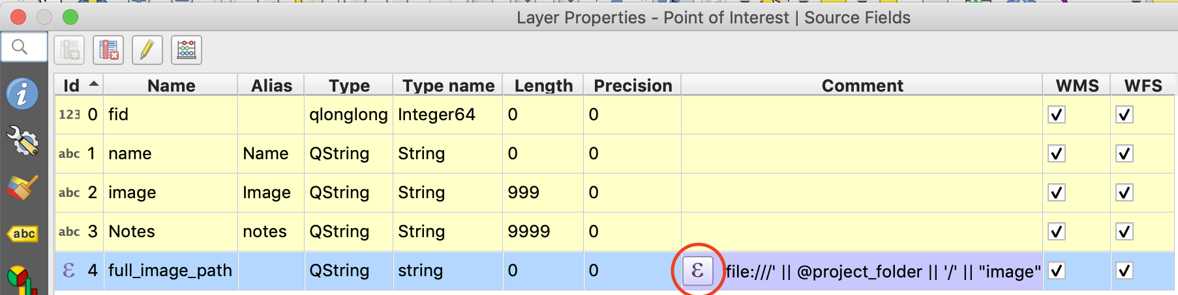

The expression will produce a full HTML friendly file path like this:

<file:////Users/timlinux/gisdata/Maceira/IMG_00000014.jpg>

Now when you view your table you should see the dynamically calculated full_image_path column:

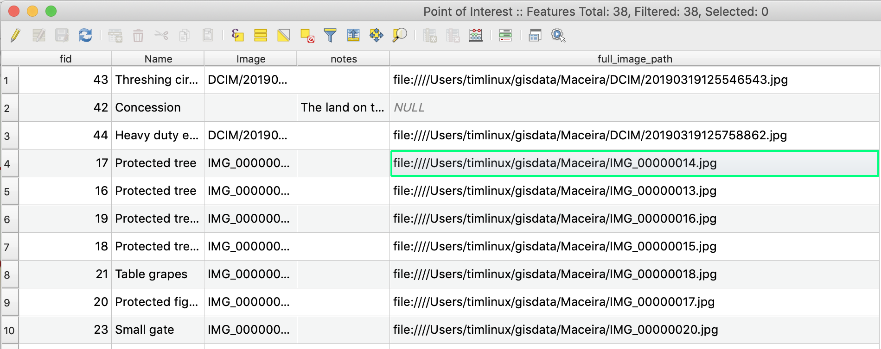

Next we want to open the layer properties for POI and set the tooltip using this calculated field:

<small>[%"Notes"%]</small>

<p><img src="[% full_image_path %]" width=300 /></p>





Now upload your project to MERGIN and long press a POI.

**** Add screenshot here ***

Use a similar process to show popup images for trees when you hover over them in QGIS…

## Using QML Form Widgets

import QtQuick 2.0

Label {  
 id: lblMsg  
 width: ApplicationWindow.width – 40  
 text: "This is a scratch layer for capturing boundary sections. Use the data you collect here to construct a boundary polygon when you are back at your desktop QGIS."  
 wrapMode: Label.WordWrap  
 style: LabelStyle {  
 label: Text {color: "black"}  
}





# Getting out into the field

## External GPS receivers

## Using INPUT in the field

## Using QField in the field

# Synchronising field data back to your office

## Synchronizing INPUT data

## Synchronizing QField data

# Further reading and resources

## More INPUT info

You can find more info on options for setting up your project with INPUT here:

<https://github.com/lutraconsulting/input/blob/user-docs/docs/users/project_config.md#image>

## Input versus QField

|  |  |  |  |
| --- | --- | --- | --- |
| **Feature** | **Input** | **QField** | **Notes** |
| Cloud Sync | Yes (Mergin) | Manual |  |
| Manual project load | Yes | Yes | You can manually transfer projects to the device using a USB cable. No cloud sync for these! |
| Capture Points | Yes | Yes |  |
| Capture Lines | Yes | Yes |  |
| Capture Polgons | No (coming soon) | ? |  |
| Virtual Layers | Yes | No |  |
| Remote Layers | Yes | Yes | Need 4G or WiFI |
| SVG Markers | Yes (manual) | Yes (automatic*) | * if using standard QGIS Markers |
|  |  |  |  |
|  |  |  |  |
|  |  |  |  |

Problems

Publishing new version of the project is hit and miss - I upload to mergin but can’t see my changes reflected on the tablet when I sync

1. Web Mapping Service / WMS: “The OpenGIS® Web Map Service Interface Standard (WMS) provides a simple HTTP interface for requesting geo-registered map images from one or more distributed geospatial databases. A WMS request defines the geographic layer(s) and area of interest to be processed. The response to the request is one or more geo-registered map images (returned as JPEG, PNG, etc) that can be displayed in a browser application.” - https://www.opengeospatial.org/standards/wms
2. Web Feature Service / WFS: “The Web Feature Service (WFS) represents a change in the way geographic information is created, modified and exchanged on the Internet. Rather than sharing geographic information at the file level using File Transfer Protocol (FTP), for example, the WFS offers direct fine-grained access to geographic information at the feature and feature property level.” - https://www.opengeospatial.org/standards/wfs